 | Monday | Tuesday | Wednesday | Thursday | Friday
9:00  9:30  Break  10:45  Lunch  1:00  1:30  2:00  2:45 | Reading -Read for 20 minutes. Then draw an illustration of one scene from the pages you have read.  Literacy-Today we will be looking at nouns. Click here and here to watch some videos and find out more! Once you’ve watched the videos see if you can spot all of the nouns on the recognising nouns work sheet. Is it a person? Is it a place? Is it a thing?  Maths-Practise the 3 times-table, you can sing along here.  Click here, then click on ‘Multiplication- Equal Groups’ and watch the video. Then have a go at the Multiplication – Equal groups worksheet.  Spelling – This week’s spelling rule is he /ɪ/ sound spelt –y at the end of words. Write each word out three times (using different coloured pens/pencils if you have them). Spelling words to practise- cry, defy, reply, July, sky, try, shy, sly, fly, butterfly OR Mrs Kukus’s phonics group -click here to watch todays video. Reading video here, spelling video here.  IXL (recommended maths activities)  RE-  Click here to find out how Hindus worship at home, and click here to find out how Hindus worship at a Hindu Temple. Then have a look at the Hindu place of worship presentation. Use this to complete the Hindu place of worship worksheet. What practises do Hindus do at home?  What practise occur in the Hindu Temple?  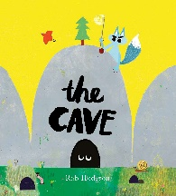  Are there any practises that occur at home and at Hindu temples?  Enjoy an amazing story of your own story or click here to listen to ‘The Cave’ | Reading-Read for 20 minutes. Find the meaning of three words that you did not know and write them down, add the words to your new vocab list.  Literacy- Today we will be looking at verbs. Click here and here to watch some videos and find out more! Once you’ve watched the videos see if you can spot all the verbs on the recognising identifying verbs worksheet.  Maths-Practise the 4 times-table, you can sing along here.  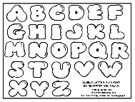  Click here, then click on ‘Multiplication using the symbol’ and watch the video. Then have a go at the ‘Multiplication using the symbol’ worksheet.  Spelling –Write each of your spelling words in bubble writing and then colour the words in.  Mrs Kukus’s phonics group -click here to watch todays video. Reading video here, spelling video here.  IXL (recommended maths activities)  Science- This week we will be looking at the different types of teeth we have in our mouth.  Click here to find out about the different type of teeth and their function. Have a look at the Types of teeth and their function PowerPoint presentation. Use your new learning to help you with the activities on the Tooth types worksheet.  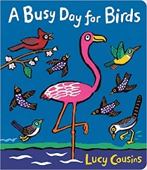  Enjoy an amazing story of your own story or click here to listen to ‘ A busy day for Birds’ | Reading-Read for 20 minutes. Explain to an adult what has happened so far in your story.  Literacy- Lets have a look at adverbs. Click here and here to watch some videos and find out more. Once you’ve watched the videos, Log in to Purple Mash to find your ‘2do’. It is called ‘Adverbs quiz’. Let’s see how well you know your adverbs!  Maths-Practise the 6 times-table, you can sing along here.  Click here, then click on ‘Using Arrays’ and watch the video. Then have a go at the ‘ Using Arrays’ worksheet.  Spelling – Write an exciting sentence for each of your spelling words.  Mrs Kukus’s phonics group -click here to watch todays video. Reading video here, spelling video here.  XL (recommended maths activities)  Computing-  Let’s work on our animation skills! Go to Purple Mash and complete the 2do ‘2 Animate’. If it’s a bit tricky, click on the green play button at the top of the page to see what you have to do. I can’t wait to see how creative you’ve all been!  Enjoy an amazing story of your own story or click here to listen to ‘Astro Girl’ | Reading- Read for 20 minutes. Write a short letter to your favourite character telling explaining why they are your favourite.  Literacy- Today we will be looking at adjectives. Click here and here to watch some videos and find out more! Once you’ve watched the videos see if you can sort the adjectives into the correct group, on the Adjectives sort worksheet.  Maths- Practise the 8 times-table you can sing along here.  Click here, then click on ‘5 Times-table’ and watch the video. Then have a go at the 5 Times-table worksheet.  Spelling – write a definition for each of your spelling words, you can use a dictionary, the internet or maybe ask an adult to help.  Mrs Kukus’s phonics group -click here to watch todays video. Reading video here, spelling video here.  IXL (recommended maths activities)  PE -with Joe Wickes  Click here and get moving!  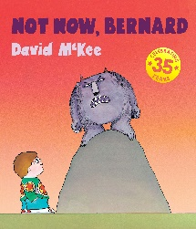  Enjoy an amazing story of your own story or click here to listen to ‘ Not Now, Bernard’ | Reading- Read for 20 minutes.  Literacy-  Today you are going to use all of your literacy learning from this week to help you with today’s task. Re- watch the literacy videos for nouns, verbs, adverbs and adjectives. Once this has been done, you will be identifying different parts of a sentence- including nouns, verbs, adjectives and adverbs.  Maths- Let’s see how many we can remember. Log in to Purple Mash to find your 2do for today. It is called Multiplication. Learn your times tables and test yourself with the multiplication tables check. Click, and click on ‘Make equal groups- Sharing,’ and watch the video. Then have a go at the make equal groups- Sharing worksheet.  Spelling- Complete the Spelling word search, can you find all the words? Or create a word-search of your own using the spelling words.  Mrs Kukus’s phonics group -click here to watch todays video. Reading video here, spelling video here.  IXL (recommended maths activities)  History- Click here to listen to the Mayan Chocolate tree story. Then have a looks at the Chocolate timeline presentation. Use the presentation to help you match the correct event to the correct date. Then put them in the right order, if you find this a bit tricky you can ask an adult to help. After all of that hard work Use their Maya hot chocolate recipe to treat yourself to some traditional Mayan hot chocolate.  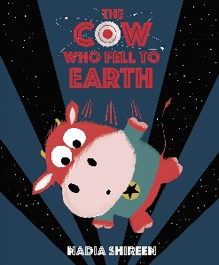  Enjoy an amazing story of your own story or click here to listen to ‘The cow who fell to earth’

