 | Personal, Social and Emotional Development | Physical Development | Communication and Language | Literacy | Mathematics | Understanding the World | Expressive Arts and Design
Monday | https://www.youtube.com/watch?v=Nb2msIQo6TI  Listen to the story “Rainbow Fish” together. Discuss sharing and different ways you can be nice (letting your siblings and friends play with your toys, sharing your sweets etc.)  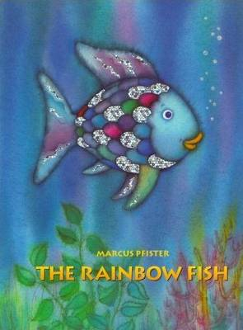 | https://www.youtube.com/watch?v=2X1p0Yd6WAo Today Joe is doing a Spiderman workout!  After the workout, can you practice writing your name? | Encourage your child to talk about their favourite sea creature and discuss any sea creatures they may have seen at the beach, in a fish tank or at a zoo or aquarium.  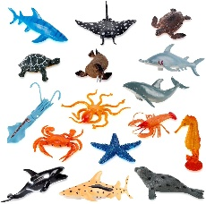 | https://www.youtube.com/watch?v=Nb2msIQo6TI Listen to the story “Rainbow Fish”. Stop the story from time to time and encourage your child to think about what might happen next.  Phonics: Guess The Sound https://www.youtube.com/watch?v=h0Kp_J9kvNM | Write the numbers from 1 to 5 on pieces of paper. Play ordering games, missing number games, matching and counting games (ask your child to put 3 forks on the paper with the number 3, 4 buttons on the paper with number 4 etc.) | https://www.youtube.com/results?sp=mAEB&search_query=how+are+rainbows+made+for+kids  Have a look at how rainbows appear in the sky! | https://www.youtube.com/watch?v=kIFXZdpnLi8  Try to encourage your child to practice holding a pencil correctly. You can draw some smiley faces!  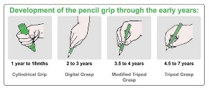
Tuesday | Think about what does it mean to be a good friend? Listen to the song bellow together and look at all the characteristics of a good friend  https://www.youtube.com/watch?v=avHdx18pi_U | https://www.youtube.com/watch?v=z2UQ5-cVHjs  Ocean yoga today!  Can you stretch like a shark?  You can also practice putting your socks on today! | https://www.youtube.com/watch?v=-aE1lALKV9M Can you do some cooking today? You can shape your biscuits as fish, octopuses or turtles! I hope you will do some good listening and following instructions!  I have added a different recipe at the bottom of the page.  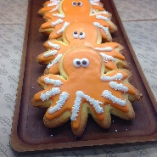 | The children could write a letter to Rainbow Fish asking what games he likes to play with his new friends. Or they can try and draw their favourite game.  Phonics: Guess The Sound https://www.youtube.com/watch?v=yT8u1ge58jc  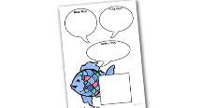 | Watch this lesson from Oak National Academy. Try and sort some objects from your house based on one attribute. Can you find some red objects? Can you find some plastic objects? Etc. Please, be patient! The lessons are loading slowly, but they are really good. https://classroom.thenational.academy/lessons/sorting-a-collection-of-objects-based-on-one-attribute-70r32t?activity=video&step=1 | https://classroom.thenational.academy/lessons/to-identify-different-creatures-that-live-under-the-sea-75hkjt?activity=video&step=1  This lesson from Oak Academy has a story, “under the sea” vocabulary and instructions to make a sensory bottle.  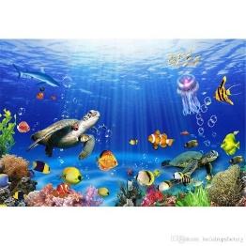 | https://theimaginationtree.com/40-fine-motor-skills-activities-for-kids/  Have a look at the imagination tree website. It has many ideas on how to improve your child’s fine motor skills by using things you have around the house! I like the pasta necklace!  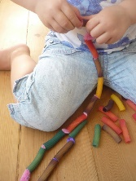
Wednesday | Give your child a small task to do. It can be tiding up the toys after playing, helping you set or clear the table, making their beds, water the flowers or bring in the mail. Chores help kids learn responsibility, and sharing chores gives you help around the house. It is also good for their self-confidence to know that you trust them with some tasks. | https://www.youtube.com/watch?v=EXt2jLRlaf8  8 minutes workout today! Let’s try to keep up! | Look at the video together  https://www.youtube.com/watch?v=3237-AJLJ7Q  After watching, try to remember as many sea creatures as possible!  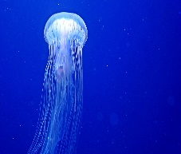 | Phonics: Guess The Sound  https://www.youtube.com/watch?v=4GhEGU0wUc0  Rainbow starts with the sound ‘r’. Can you look around the house and find as many objects starting with the same sound? Can you think of some names or animals that start with the sound ‘r’?  https://www.storylineonline.net/ has so many lovely stories. Perfect for before bedtime! | Can you try to sort your toys based on one attribute? Can you sort your lego bricks based on colour? Then try and sort them by size. Can you sort your cars by colour? Can you sort your dolls by size?  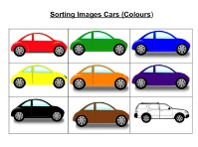 | Try to talk together about a special day. It can be a birthday, a trip or a visit to a loved one. What can you remember? How were you feeling? How was the weather? Why was that specific day special to you? | We really love singing the Rainbow song in our classroom. Can you keep practicing it to make sure you will remember all the colours of the rainbow when we come back to school?  https://www.youtube.com/watch?v=nRTdq0VsLGQ
Thursday | Discuss what it means to feel ‘lonely’ and why Rainbow Fish felt lonely. What can we do to stop people feeling lonely? Watch the video together and discuss what can you do to feel better. https://www.youtube.com/watch?v=DnOhzx1byb0  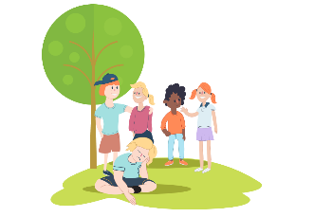 | https://www.youtube.com/watch?v=qC83oFEeVZA  Yoga under the sea! | Discuss what a submarine is and what it might see on a journey under the sea – might they see Rainbow Fish?  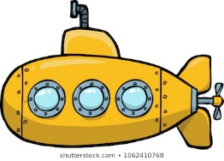 | https://www.youtube.com/watch?v=oqupxANpqIE “The Pout, Pout Fish”  You can spread happiness around you or you can be pouty. Can you join in with the little song?  Phonics :Guess the sound https://www.youtube.com/watch?v=vGRKZ-tctvM | Have a go at the biscuit recipe from the bottom of the page. Ask your child to help you with following the steps and weighing the ingredients.  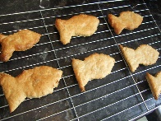 | https://www.youtube.com/watch?v=HQTUWK7CM-Y  Our oceans are getting so polluted. Let us see what is going on and how we can stop that!  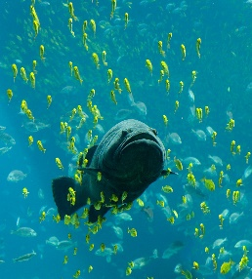 | Do not throw away the toilet rolls. We will use them for some of our projects on the following weeks. Like this cheeky octopus. You can make 8 or more legs and you can try to write a number on each of them.  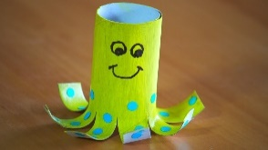
Friday | Sesame Street has a lovely video explaining what does it mean to be a friend. Have a look and discuss with your child situations when they have been good friends.  https://www.youtube.com/watch?v=iPux6QAkBdc | https://www.youtube.com/watch?v=5MBEyQIlrfo  Go, go nursery! | Provide opportunities for the children to discuss their favourite sea-themed television programmes and films. Describe and create adventures for the characters. | https://www.youtube.com/watch?v=Jn1FBkrHNKg Listen to the story “Barry the Fish with Fingers”. What makes you special?  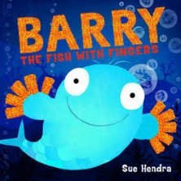  Phonics :Guess the sound  https://www.youtube.com/watch?v=VdTzAVSnY1w | https://www.bbc.co.uk/teach/school-radio/nursery-rhymes-five-currant-buns/zm4nmfr  Practice counting the buns! Can you find a penny and pretend that you are paying for the bun?  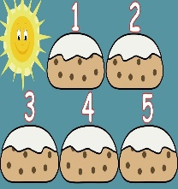 | https://www.youtube.com/watch?v=hXtrIy95V80  So many wonderful creatures live in our seas and oceans. That shark scared me a little! Can you name some of them?  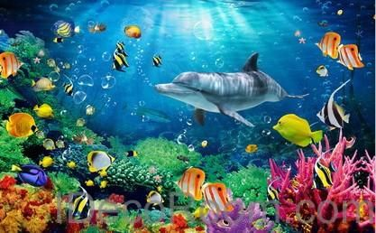 | You don’t need brushes to paint a rainbow fish, you need celery sticks! Count the marks from the paper as you make them. How many yellow ones did you do?  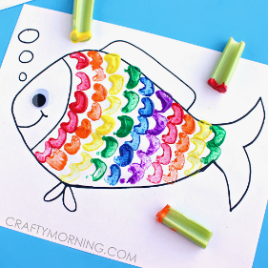

This week we are focussing on “Rainbow Fish” by Marcus Pfister. The activities above are suggestions to get you started in supporting your child’s learning. Please, feel free to adapt them to your child’s level and include their interests as well. Children learn best through play, so make sure you are encouraging curiosity and let them use and develop their imagination. Work your way through the activities at a pace that works for you and your child. Try to turn off any distractions (e.g. the TV) and create a space where you can learn together. Keep it fun and keep each session short – maybe half an hour. The most important thing you can do is to carry on speaking with your child, to support their language development and to listen to their concerns at this time. If you require any support with your child’s Home Learning, please do not hesitate to email admin@st-marys.lewisham.sch.uk or ring 0208 6902613.

