Reception Home Learning – Spring Term – w/b 18.01.21

We would to love to receive some photos showing your child’s home learning. Please send to admin@st-marys.lewisham.sch.uk if you are happy to share.
We also have paper copies of plans available from the Reception desk at school, if you find these easier to work from.
Week 2 | Monday | Tuesday | Wednesday | Thursday | Friday
PE | It’s warm up time!  (https://youtu.be/MugzDjGDYjo)  This is one of our favourite warm ups in Reception. 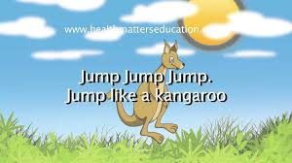 | PE with Joe  https://youtu.be/N7CX0_7sLTA  Can you help Zara keep up with Joe? | This dance workshop is based our story Goldilocks & the Three Bears. (https://youtu.be/MsY6YP2ZN-k)  If you find a bit long, do half in the morning and half in the afternoon. | PE with Joe  https://youtu.be/EXt2jLRlaf8  This workout is a bit longer – 8 minutes – have a go! What do you notice after you have done exercise? Can you feel your heart beating? | PE with Joe  https://youtu.be/E5cmJpSFZB8  Let’s try another 8 minutes of exercise.
Literacy  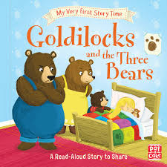 | This week we are reading a different traditional tale – Goldilocks & the Three Bears  https://youtu.be/0oUP2PFeOi8  Goldilocks was quite a naughty girl. Can you remember all the naughty things she did? | Listen to the story again.  https://youtu.be/0oUP2PFeOi8  How do you think the bears were feeling when they saw what Goldilocks had done?  What do you think Goldilocks should say to the bears? | Pretend you are Goldilocks and make a card for the bears to say you are sorry.  Write a message to the bears inside. Send me a photo of your card – I would love to see it! | The Three Bears liked porridge for breakfast. What do you like? Have you had porridge?  Draw a picture of your favourite breakfast foods and label them, using your sounds. | Watch this short film about bears.  https://youtu.be/54CDgurNMSI  Can you remember how many different types of bear there are? Which one is your favourite? Can you tell me why?  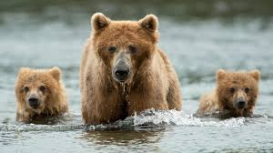
Phonics | 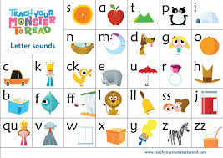  Don’t forget to use your Teach your monster to read log-in! It’s a great resource. | Now watch the phonics video for e and then practice writing it on paper.  https://schools.ruthmiskin.com/training/view/5bIuHTox/pURxXprc  How many words can you think of, that start with e? | Watch the phonics video for r and practice writing it. Can you think of a word that starts with r?  https://schools.ruthmiskin.com/training/view/QWVUfbCC/1F45UEJj  Now have a go at sounding out and writing these words:  red  rat  rug  rip  rag | Watch the video for u and practice writing it. You usually find this sound in the middle of words.  https://schools.ruthmiskin.com/training/view/IyZsyJKj/wp6y07uT | Watch the video for b  https://schools.ruthmiskin.com/training/view/PZ3wt7Xw/CFPSYuAH  Can you think of some words that start with this sound?  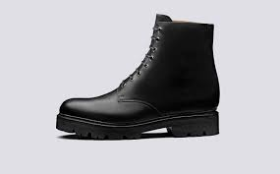
Maths  Alive in 5 | Week 2, session 4  How many are hiding?  https://whiterosemaths.com/homelearning/early-years/alive-in-5-week-2/  Find 5 toys. Hide some under a cushion. How many can you see? Can you work out how many are under the cushion? | Week 2, session 5  How many are hiding?  https://whiterosemaths.com/homelearning/early-years/alive-in-5-week-2/  This time play a game with your parent. Get the 5 toys and hide some. Can they guess how many are hidden? Then swop, let them hide some toys. Can you work out how many are hidden? | Week 3, session 1  Today we are looking at heavy and light. Watch the film as it shows the balance scales.  https://whiterosemaths.com/homelearning/early-years/alive-in-5-week-3/  Now find some objects to weigh in your hands. Can you say which is heavier and which is lighter?  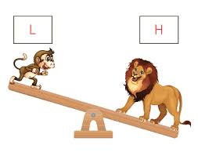 | Week 3, session 2  Full and empty  Let’s think about the different words we can use to describe how full a container is.  https://whiterosemaths.com/homelearning/early-years/alive-in-5-week-3/  With your adult, fill a class so that it is full, nearly full (and when you’ve finished drinking)  empty! | Week 3, session 3  Measuring capacity  Let’s talk about how much different containers hold.  https://whiterosemaths.com/homelearning/early-years/alive-in-5-week-3/  Find some different containers in the kitchen. Which pot would hold the most rice?
Songs & games  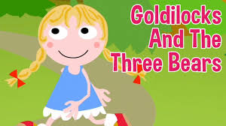 | Join in with this Goldilocks song. Can you remember some of the actions?  https://www.bbc.co.uk/teach/school-radio/nursery-rhymes-when-goldilocks-went-to-the-house-of-the-bears/zbkrf4j | You will need to do your best listening to guess the animal from these sounds.  https://youtu.be/Qd6wZHUDCUg?list=RDCMUChf0ErPjca3wGIuaBlOrMhg  How many did you get right? | This is a great counting song about 10 teddies who keep falling out of bed. Can you work out how many teddies are left each time? | Now listen to the story based on this song.  https://youtu.be/ZnhP9P7Obfc  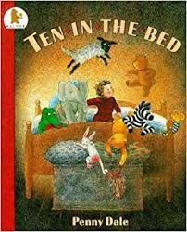 | Our final bear rhyme – Teddy bear touch your toes – make sure you follow all the actions  https://youtu.be/76wc4xdgzGk  